MEMORANDUM 36-17HR

TO: Agency Administrators

FROM: Carolyn Horwich, Esq., Director of Human Resources

THROUGH: Rip Colvin, Executive Director

SUBJECT: Open Enrollment Questions and Answers

DATE: October 12, 2017

OPEN ENROLLMENT FOR THE 2018 PLAN YEAR
Q&A
Open Enrollment: Monday, October 16, at 8 a.m. through Friday, November 3, 2017, at 6 p.m.
(All times Eastern)
Please visit mybenefits.myflorida.com/health/open_enrollment2

Health Insurance

Please see the updated list of HMO contracted service areas at mybenefits.myflorida.com/health/open_enrollment2/2018_health_plan_options

Q1. Regarding the HMO county change, this only applies to a person who is enrolled in an HMO? It will not apply to people enrolled in the Florida Blue PPO?

A. Correct. The contacted services areas apply to the four HMOs the State of Florida offers. Florida Blue is a PPO plan and is offered nationwide.

Q2. What if we have a person who is living out of state (in GA) but works here in Florida? Will anything change for them?

A. Employees who are living out of state can choose either the Florida Blue PPO plan or the HMO available in their work county.

Q3. Hypothetical: Maria lives in Charlotte County. Her HMO is Aetna. Her pulmonologist accepts Aetna but the county’s HMO where the pulmonologist is located isn’t Aetna – it’s AvMed. She can still see her pulmonologist since she accepts Aetna, even though that county’s HMO is AvMed, correct? Doctors can be under contract with both HMOs, right?

A. If a provider is a network physician for the selected plan, where they are located is not of consequence. It is the network vs. out-of-network designation that is the determining factor regarding coverage availability. Doctors can be under contract with multiple HMOs.

Q4. I noticed that the HMOs are changing next year and only one will be offered per county. I plan on moving to another county next summer that does not offer the HMO I am currently with – I assume that will be a qualifying event which will allow me to change health plans at the time I move, that being the HMO offered in my new county?

A. You may elect the HMO in either your work OR your home county. If you select your HMO based on your home address AND you have a dependent, you will have a QSC event to change HMO providers within 60 days of your move. This is considered a QSC because your dependent cannot be required to go to your physical work county for medical care. If you do not have a dependent AND are still eligible for the HMO based on your work address, you will not have a QSC event to change HMO providers.

Q5. Since an employee can elect their HMO provider based on either their home or work address, is the work address based on the physical county the employee’s office is located in or the headquarter county?

A. The HMOs available to employees are based on their home or physical work address. The physical county code entered on the position description is the county in which People First will use in determining an employee’s eligibility.

Q6. Where can I find an employee’s physical work county? How do we correct the physical work county if it is incorrect?

A. Your monthly Rate Reports show the physical work county in Column D. If the information in Column D is incorrect for any of your employees, please submit a Position Description with both the “New Headquarters/County Code” and the “New Position County Code” even if they are the same. Below is what the screen looks like on the Position Management side of People First.

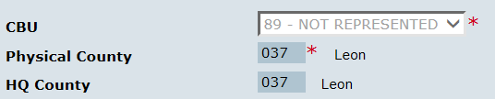

If you would like to check a particular employee’s home address in People First, go to Personal Information Maintenance -> Contact Information -> and select Home Address. The home and (physical) work county codes will be displayed.

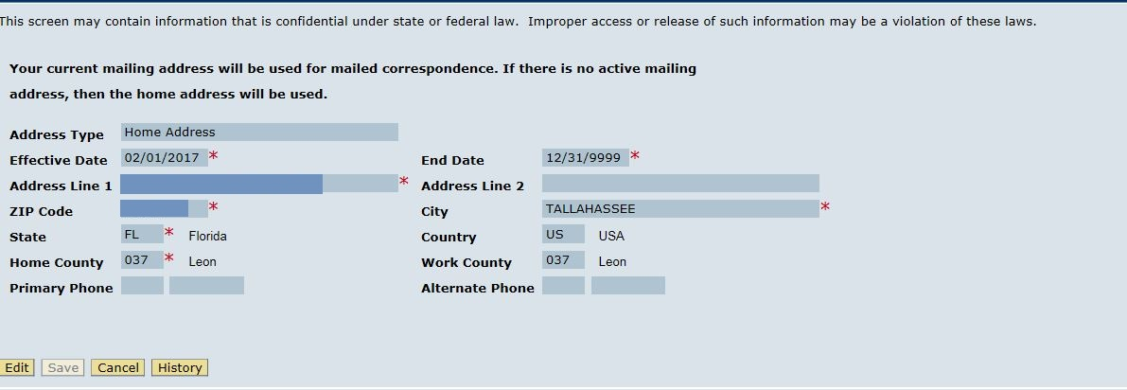

Q7. Am I understanding correctly that employees who were HMO-Florida Health Care cannot choose/change to Florida Blue during open enrollment? Their options are still HMO or PPO?

A. Employees have the option to choose from the PPO plan (Florida Blue) or the designated HMO plan offered in either their home or physical work county. Please be aware that if the employee is currently enrolled in an HMO and they do not actively elect a plan, their health insurance will default to the HMO provided in their home county.

Q8. Will the change in HMO plan also affect use of plan? For example, if the provider is in-network, you can make your own appointment without a referral. Our current HMO covers limited outside of FL coverage for emergency situations, will the new plan?

A. Standard HMOs cover only in-network services, except in certain emergency situations. You pay copayments for services provided in the HMO’s network, and you may be required to have a primary care provider and referrals to see some specialists. All HMO contracts are standard and usage of the plans should be identical. For plan specific questions, please contact the provider directly. On the myBenefits site, you can find the benefits brochure for the PPO and four HMO plans offered to the State of Florida employees. mybenefits.myflorida.com/health/open_enrollment2/2018_health_plan_options

Q9. Where can I find a list of network providers for my health insurance plan?

A. Your health insurance company may have a listing of network providers on its website, including links and phone numbers. Your health plan's member services can also help you locate a network provider. Contact information for each health care plan can be found on the myBenefits website, inside the plans brochure.

Q10. An employee is trying to check if their medical providers are contracted with UnitedHealthcare. On the welcometouhc.com site, find doctors, the next page asks what Plan Are You Looking For? What Plan should they select since it doesn’t show State of FL on the list?

A. The UnitedHealthcare Brochure on the myBenefits site does not have the plan name. The link found in the brochure, welcometouhc.com/ﬂorida, links you to the State of Florida page. There are several ways to search for a doctor on this page and they all take you right to their choice page without asking for the plan name.

Q11. One of my employees seems to think that her AvMed policy is a PPO. Is there such a thing? I thought AvMed was an HMO and that’s all.

A. We do not have a list of all AvMed products. They may offer PPO plans. However, the plan that is offered through AvMed to State of Florida employees is an HMO plan. The State of Florida PPO plan option is Florida Blue. You may want the employee to check her current benefits in People First.

Q12. One of our employees who has health insurance has a son who is 24 years old and currently covered as a dependent. She asked me if she could remove him this year, then add him back next year. He would still be age-eligible.

A. At this time the only requirement for a dependent child to be covered is to be under 26 years of age. So, if the rules don’t change, your employee can drop her dependent during open enrollment for the 2018 plan year. However, in order to add the child back onto her plan, she would have to have a QSC event to add him for 2018 or wait until open enrollment for plan year 2019. In other words, if the employee removes the child for the plan year 2018, she will not be able to add him back unless a QSC occurred or she waits until the next year’s open enrollment

Q13. I live and work in Purple County. However, my children live in Green County. I want to make sure that I chose the correct HMO option so that they will remain covered. I am not sure how to go about this.

A. If you keep your PPO, nothing will change. However, if you change to the Aetna HMO, you will need to contact each of your children’s providers in Pasco and ask them if they accept Aetna coverage. You can also go to Aetna’s website and see if your children’s providers are listed within the Aetna network.

Dental Insurance

Q1. Would it be possible to have a list of all of our employees and what dental plans they are enrolled in so we can narrow down who definitely needs to make their dental changes?

A. Yes. JAC will be more than happy to provide you with a list of employees whose dental coverage is changing or being canceled. If you would like such a report, please contact benefits@justiceadmin.org.

Q2. I was just looking over the new benefits and don’t understand why on the Dental Plan they have Humana Select 4044 and Humana Schedule B (4084) as providers but when you click on the link it takes you to the other option codes (4004 and 4054) which are no longer providers.

A. On the myBenefits website, under the Open Enrollment tab, select Dental. Once you scroll down, there is a list of all the dental plans available in 2018. If you click on Humana Select 15 (4044) and Humana Schedule B (4084) dental plans, it will take you to the Humana website, which provides you with the plan details.

Q3. Is there a waiting period for some dental services if an employee had a dental plan and has to change plans?

A. Some dental plans offered in 2018 require a waiting period for Orthodontia services. For more information, please visit mybenefits.myflorida.com/health/open_enrollment2/2018_dental_options.

Q4. Did you guys get any guidance about folks who must change dental plans? I have an employee who has waited a year on her current plan to get braces, and now is being shifted to another plan just when she would have been eligible for braces in January.

A. We have not been given guidance on the impact of services because of a dental plan change. Unfortunately, this could be a specific plan provider question. Employees can contact the 2018 plan providers and ask if there is any provision in their plans that would allow the employee to waive the waiting period based on the dental plan change. Just as a reminder, employees are not being defaulted into new plans. She will have to make an active dental plan election if she is currently enrolled into a plan expiring in December.

Q5. We have a retiree who is on COBRA and has dental insurance. That retiree’s dental plan is being discontinued but the employee still has several months left under COBRA. Will that person be able to select a new dental plan?

A. Yes, COBRA participants will be able to select a new dental plan during open enrollment. Information for the dental plans that will be offered for 2018 is on the myBenefits site at mybenefits.myflorida.com/health/open_enrollment2/2018_dental_options. Please note – retirees on COBRA will need to call the People First Service Center to make the change.

Q6. I contacted MetLife to see if my dependent would be covered because I saw something on their website brochure that said that dependents up to age 26 are covered if they are a full time student. My son is only a part time student in college. He will be 25 next year. I plan to cover him on my insurance until he is 26. MetLife could not answer my question. They said I would need to contact DMS to see if my dependent is covered. How do I find out if the insurance companies are limiting the dependent coverage to only full time students?

A. All State of Florida plans offer coverage to dependents until the end of the year in which they turn 26. No other restrictions apply for standard dependent coverage.

General Information

Q1. How does Open Enrollment and New Hires for this month coordinate with enrollment period?

A. As always, please have new employees select their new hire benefit elections first and then select their open enrollment changes for the 2018 plan year second. New hires will not be able to elect one of the new dental plans when electing their benefits for the 2017 plan year. In this case, some employees may have to elect one dental plan for 2017 and a different dental plan for 2018.

Q2. When making QSC changes online in People First, do employees wait until People First asks for supporting documentation before sending it in? In other words, will PF let the employee know what they need to send?

A. Employees will need to call People First to make changes to their insurance. Birth, adoption, divorce, death, Medicare disability and Court Orders require documentation. If an employee experiences one of these events, please have the employee send the requested documentation to People First within 60 days of the event.

Q3. How can employees get their current benefits confirmation statement?

A. Employees can find their current benefit statement on the People First website. Under My Quick Links, select Benefits Confirmation Statement and then select the year the employee wishes to view. Employers can view their employees benefit statement under the Benefits tab. Select Confirmation Statement and the year that you wish to view. If an employee is having trouble viewing their benefit statement, please contact benefits@justiceadmin.org and JAC will provide you with the information.

Q4. Where can an employee check what benefits they will be enrolled in for 2018?

A. Employees will receive a 2018 open enrollment benefits summary page in the mail. This summary will show the employees current enrollment for 2018, prior to any open enrollment elections. In People First, employees can also view their current benefits under the Health & Insurance tab, select myBenefits and then enter 1/1/2018 for the “as of” date.

Q5. Premium payments should be checked on December warrants for January premiums, right?
A. Most benefits are paid a month in advance. For instance, health insurance premiums paid in December are for January’s coverage. Tax favored accounts contributions are taken out the month of the same month’s warrant. For example the employee contribution for January is taken out of the employee’s January 31st pay warrant. Please have employees check both their December 29th and January 31st pay warrants to ensure all of their benefits premiums were properly deducted.

Q6. Is the Heath Savings account and MRA card the same thing? I am thinking about signing up for the MRA card during open enrollment and was not sure about how to do that.

A. A Health Savings Account (HSA) plan and a Healthcare Flexible Spending Account (FSA) plan (formally known as MRA) are not the same. In order to be eligible for the HSA plan you have to be enrolled into a high deductible health care plan. If your current health plan is a standard HMO or PPO you need the Healthcare FSA plan option.

Q7. Do you know if someone could come to the offices to discuss the 2018 benefits?

A. We have been advised by the Division of State Group Insurance that having providers travel to the individual circuits is not an option. Please have employees use the myBenefits site and/or contact the providers directly.

