Verify the Capital Asset Report is ready to submit to JAC’s Financial Services
- Does the Capital Asset Report (CAR) have the correct beginning balances?
- Locate the Capital Asset fund (e.g., 80-9-000XXX) on the Trial Balance (TB) Report. Note: you need a report that has no month-to-date amounts such as the one ran 7/5/24.
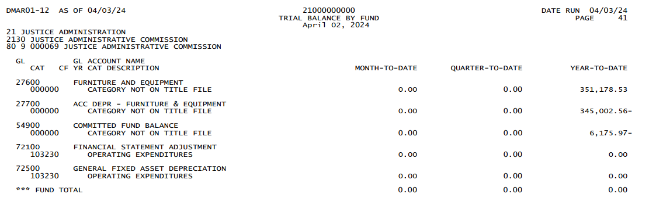
- Close the Year-End Inventory and generate the Depreciation Totals by FLAIR Asset Class Report or use your system data to complete the Non-BOMS CAR workbook provided by JAC. See the Job Aid for Year-End Inventory Depreciation Report for BOMS Users if additional guidance is needed to create this report.
BOMS Report
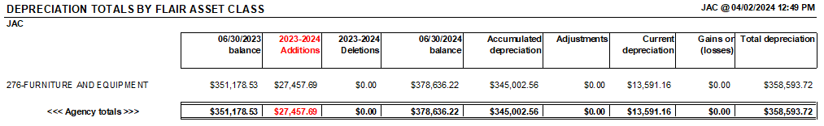

Non-BOMS report
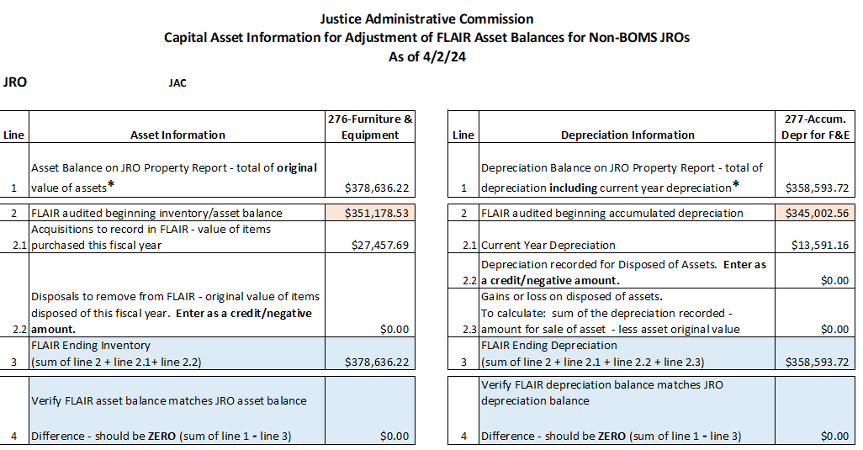
- Does the Asset Account GLs (e.g.,27600 GL) on the Capital Asset TB equal the Capital Asset Report (CAR) beginning balance? See BLUE boxes on both reports.
  - If assets were entered with a date before 7/1 of the current fiscal year (e.g., 7/1/23) after the FY 2022-23 Inventory was closed, the beginning balance will be impacted. Identify the assets causing the beginning balance to change. Verify the asset was entered correctly. Fix the asset if necessary. If correct, document which asset changes impacted the beginning balance and why entering it with a prior year received date was required.
- Does the Accumulated Depreciation (e.g.,27700 GL) on the Capital Asset TB equal the CAR Accumulated Depreciation balance? See RED boxes on both reports.
  - If assets were entered with a date before 7/1 of the current fiscal year (e.g., 7/1/23) after the FY 2022-23 Inventory was closed, the accumulated depreciation will also be impacted. Confirm that the change is caused by the same asset documented in step A.2
  - If the useful life of an asset is changed, the accumulated depreciation will also be impacted. Verify if the change was appropriate. Fix the asset’s useful life if necessary. If correct, document which asset’s useful life was changed and why it was required.
- Send the above documentation outlining why the beginning balance(s) changed to Financial Services after step B.4 (below) is reconciled and the CAR is ready for submission.

- Does the Capital Asset Report Additional column match the OCO purchases shown on the 6/30 TB for the current fiscal year (e.g., 6/30/24)?
- Background
a. The 5XXXX object code indicates if a purchase should be added to the inventory. It identifies if a purchase is OCO or an attractive item
- All OCO Expenditures are recorded in 721XX
- Attractive items (non-OCO) are not depreciated. Payments should be batched using Object code 519032 tied to GL 71100 Expenditures-Current
- OCO items are depreciated. Payments should be batched using any of the other 5XXXX object codes tied to GL 72100 Expenditures – OCO
  - A list of 5XXXXX object codes for asset purchases is posted to JAC’s website.
  - The BOMS Depreciation Totals by FLAIR Asset Class report should only contain OCO assets.
  - OCO Expenditures must have an exact offsetting entry in the Capital Asset Fund (80-9-00XXXX)

- JAC’s Trial Balance (TB) showing OCO purchases
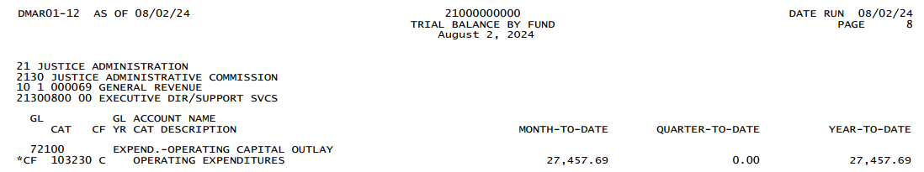

- Compare to the same reports referenced in step A.2 above.

BOMS Report

Non-BOMS report

- Does the Expenditures OCO (e.g.,72100 GL) for all Trial Balances equal the CAR Additions? See BLUE boxes on both reports.
  - If the Trial Balance Expenditures do not equal the CAR additions, a reconciliation will need to be completed that identifies:
    - Where are any OCO purchases left off the CAR? If an asset was left off, reopen the inventory year in BOMS and add the assets. Then repeat the steps above.
    - Were any purchases coded as OCO that did not meet the Capital Asset Thresholds outlined in CFO Memorandum #13? If the object code on the purchase needs to be corrected to remove the purchase from the OCO GL: identify the voucher number, vendor, object code used, correct object code, and amount. Provide the documentation when requesting Financial Services to fix the expenditure and provide the needed info. Request an adjusted trial balance be run and repeat the above steps.
    - Were any OCO purchases not coded as a 5XXXXX object code? If the object code on the purchase needs to be corrected so the expenditure will be added to the OCO GL on the TB, identify the voucher number, vendor, object code used, correct object code, and amount. Request Financial Services to fix the expenditure and provide the needed info. Request an adjusted trial balance be run and repeat the above steps.
  - When the Additions equal the amounts coded with 72100 GLs on the TB, the CAR report (Excel file) is ready to submit to Financial Services.

